PROGRAM 3 (CO1)

AIM: Implementing basic arithmetic operations of simple calculator

XML

*<?*xml version="1.0" encoding="utf-8"*?>*<LinearLayout xmlns:android="http://schemas.android.com/apk/res/android"  
 xmlns:app="http://schemas.android.com/apk/res-auto"  
 xmlns:tools="http://schemas.android.com/tools"  
 android:layout_width="match_parent"  
 android:layout_height="match_parent"  
 android:orientation="vertical"  
 tools:layout_editor_absoluteX="1dp"  
 tools:layout_editor_absoluteY="272dp"  
 tools:context=".MainActivity">  
  
 <EditText  
 android:id="@+id/n1"  
 android:layout_width="wrap_content"  
 android:layout_height="wrap_content"  
 android:ems="10"  
 android:inputType="textPersonName"/>  
  
 <EditText  
 android:id="@+id/n2"  
 android:layout_width="wrap_content"  
 android:layout_height="wrap_content"  
 android:ems="10"  
 android:inputType="textPersonName"/>  
  
 <Button  
 android:id="@+id/add"  
 android:layout_width="125dp"  
 android:layout_height="56dp"  
 android:text="ADD" />  
  
 <Button  
 android:id="@+id/subtract"  
 android:layout_width="125dp"  
 android:layout_height="56dp"  
 android:text="SUBTRACT" />  
  
 <Button  
 android:id="@+id/multiply"  
 android:layout_width="125dp"  
 android:layout_height="56dp"  
 android:text="MULTIPLY" />  
  
 <Button  
 android:id="@+id/divide"  
 android:layout_width="125dp"  
 android:layout_height="56dp"  
 android:text="DIVIDE" />  
  
</LinearLayout>

JAVA

package com.example.calculator;  
  
import androidx.appcompat.app.AppCompatActivity;  
  
import android.os.Bundle;  
import android.view.View;  
import android.widget.Button;  
import android.widget.EditText;  
import android.widget.Toast;  
  
public class MainActivity extends AppCompatActivity {  
 EditText number1;  
 EditText number2;  
 Button b1;  
 Button b2;  
 Button b3;  
 Button b4;  
 float sol=0;  
  
 @Override  
 protected void onCreate(Bundle savedInstanceState) {  
 super.onCreate(savedInstanceState);  
 setContentView(R.layout.*activity_main*);  
 number1=findViewById(R.id.*n1*);  
 number2=findViewById(R.id.*n2*);  
 b1=findViewById(R.id.*add*);  
 b2=findViewById(R.id.*subtract*);  
 b3=findViewById(R.id.*multiply*);  
 b4=findViewById(R.id.*divide*);  
 b1.setOnClickListener(new View.OnClickListener() {  
 @Override  
 public void onClick(View v) {  
 float a = Float.*parseFloat*(number1.getText().toString());  
 float b = Float.*parseFloat*(number2.getText().toString());  
 sol=a+b;  
 Toast.*makeText*(MainActivity.this,"The sum is " +sol ,Toast.*LENGTH_SHORT*).show();  
 }  
 });  
 b2.setOnClickListener(new View.OnClickListener() {  
 @Override  
 public void onClick(View v) {  
 float a = Float.*parseFloat*(number1.getText().toString());  
 float b = Float.*parseFloat*(number2.getText().toString());  
 sol=a-b;  
 Toast.*makeText*(MainActivity.this,"The difference is " +sol,Toast.*LENGTH_SHORT*).show();  
 }  
 });  
 b3.setOnClickListener(new View.OnClickListener() {  
 @Override  
 public void onClick(View v) {  
 float a =Float.*parseFloat*(number1.getText().toString());  
 float b =Float.*parseFloat*(number2.getText().toString());  
 sol=a*b;  
 Toast.*makeText*(MainActivity.this,"The product is " +sol,Toast.*LENGTH_SHORT*).show();  
 }  
 });  
 b4.setOnClickListener(new View.OnClickListener() {  
 @Override  
 public void onClick(View v) {  
 float a = Float.*parseFloat*(number1.getText().toString());  
 float b = Float.*parseFloat*(number2.getText().toString());  
 sol=a/b;  
 Toast.*makeText*(MainActivity.this,"The division is " +sol,Toast.*LENGTH_SHORT*).show();  
  
 }  
 });  
 }  
}

OUTPUT

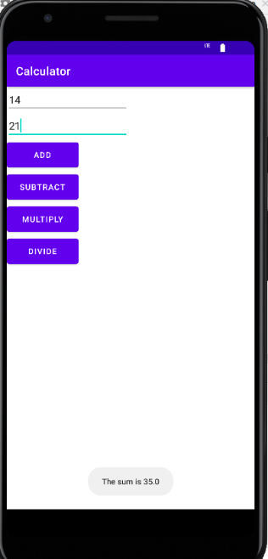

RESULT: Program to implement basic arithmetic operations of simple calculator is successfully executed and output verified